**Chef installation**

1. Go to vagrant2 server and check the desk space run the command **free –m** it shout be 1gb.
2. Go to vagrant2 file open in notepad ++ and remove the comment in below lines.

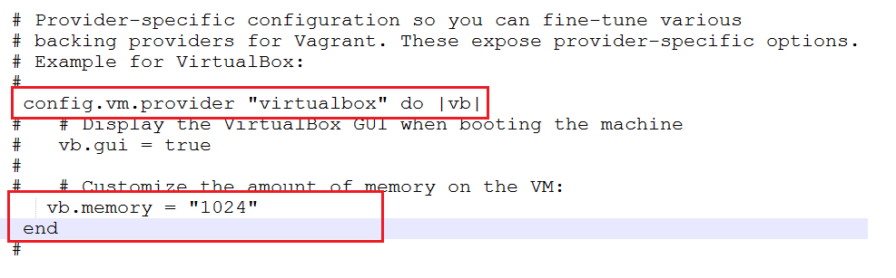

1. Copy the file from the file from local “chef-server-core-12.3.0-1.el6.x86_64”
2. Change the hostname so go to the location etc/hosts so run the below command.
3. Vi /etc/hosts and check the below screenshot.
4. 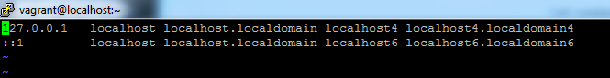
5. Then add the ip as below mentioned.
6. 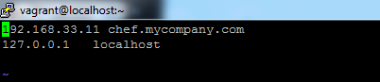
7. Go to the path vi /etc/sysconfig/network and change the file.

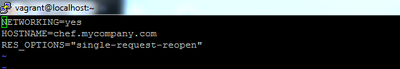

1. After that run the command rpm -ivh chef-server-core-12.3.0-1.el6.x86_64.rpm
2. Run the command chef-server-ctl reconfigure
3. 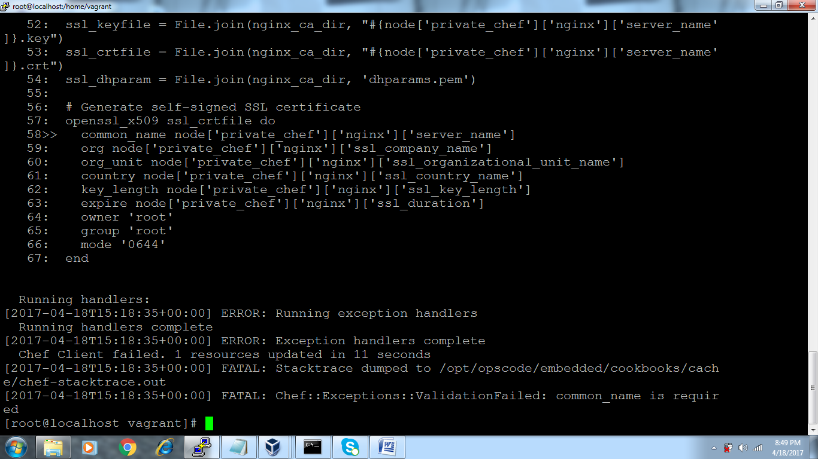
4. You will get below screen once the installation is completed.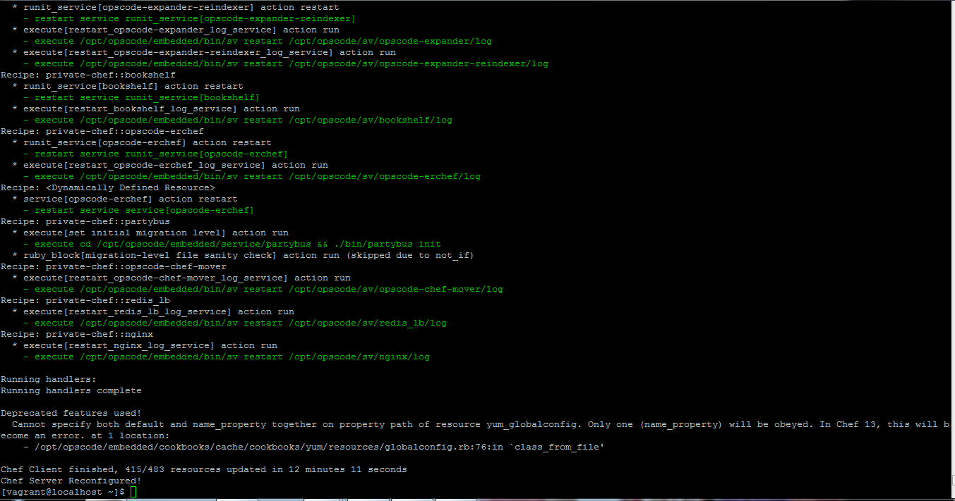
5. After that run the command rpm -ivh chef-manage-2.2.0-1.el6.x86_64.rpm
6. Run the command chef-manage-ctl reconfigure

Development kit

1. Login to the ip 192.168.33.11 and copy the file “chefdk-0.10.0-1.el6.x86_64” from the local machine.
2. And go the vi /etc/hosts and add the ip.
3. 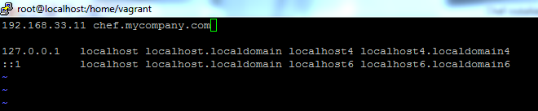
4. After that run the command rpm –ivh chefdk-0.10.0-1.el6.x86_64.rpm
5. Run the command chef- chefdk-0.10.0-1.el6.x86_64.rpm
6. Go browser and open 192.168.33.10 and create the user name and password.
7. Run the command **chef-manage-ctl reconfigure**
8. 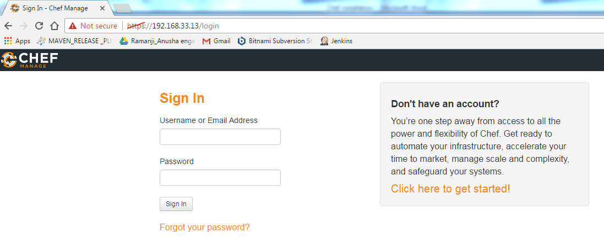
9. Create the username and password in 192.168.33.10.
10. After that run the command for login page in browser chef-manage-ctl reconfigure
11. chef-server-ctl user-create ramanji123 lakshminarayana reddy [lakshmandevops2@gmail.com](mailto:lakshmandevops2@gmail.com) Lakshman919 --filename /home/vagrant/user.pem

Red -------🡪Password

Green color---🡪Username

[lakshmandevops2@gmail.com](mailto:lakshmandevops2@gmail.com) ---🡪Email id

lakshminarayana ------🡪 firstname

reddy---🡪Lastname

1. to create the organization use below cmd
2. chef-server-ctl org-create devops "Devops ltd" --association_user ramanji123 --filename /home/vagrant/organization-validator.pem

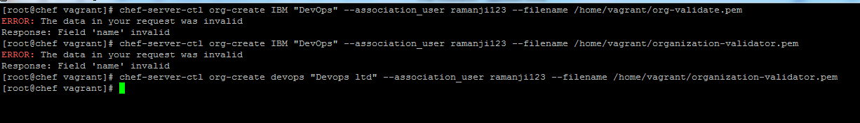

**Chef-commands:**

chef generate cookbook LeadApp

sudo chef-client --local-mode --runlist 'recipe[LeadApp]'

knife cookbook upload LeadApp

Go to chef-repo path and run below command

sudo knife bootstrap 192.168.50.12 --ssh-user vagrant --ssh-password 'vagrant' --sudo --use-sudo-password --node-name node1 --run-list 'recipe[LeadApp]'